Execute the script shown in the video.

Terraform Remote state and state locking:
=========================================
We can store terraform configuration files and state file in github or any other repository but it is not good practise.

We use s3,terraform storage,hashicorp consul to store the state file.

State locking is used to lock the state file so that no two users can execute the state file at the same point of time.

Remote backend and state locking:
================================
We can use s3 as remote backend and dynamo db for state locking.

Create s3 using terraform:
=========================
resource "aws_s3_bucket" "s3_bucket" {

bucket = "s3backend"
acl = "private"
}

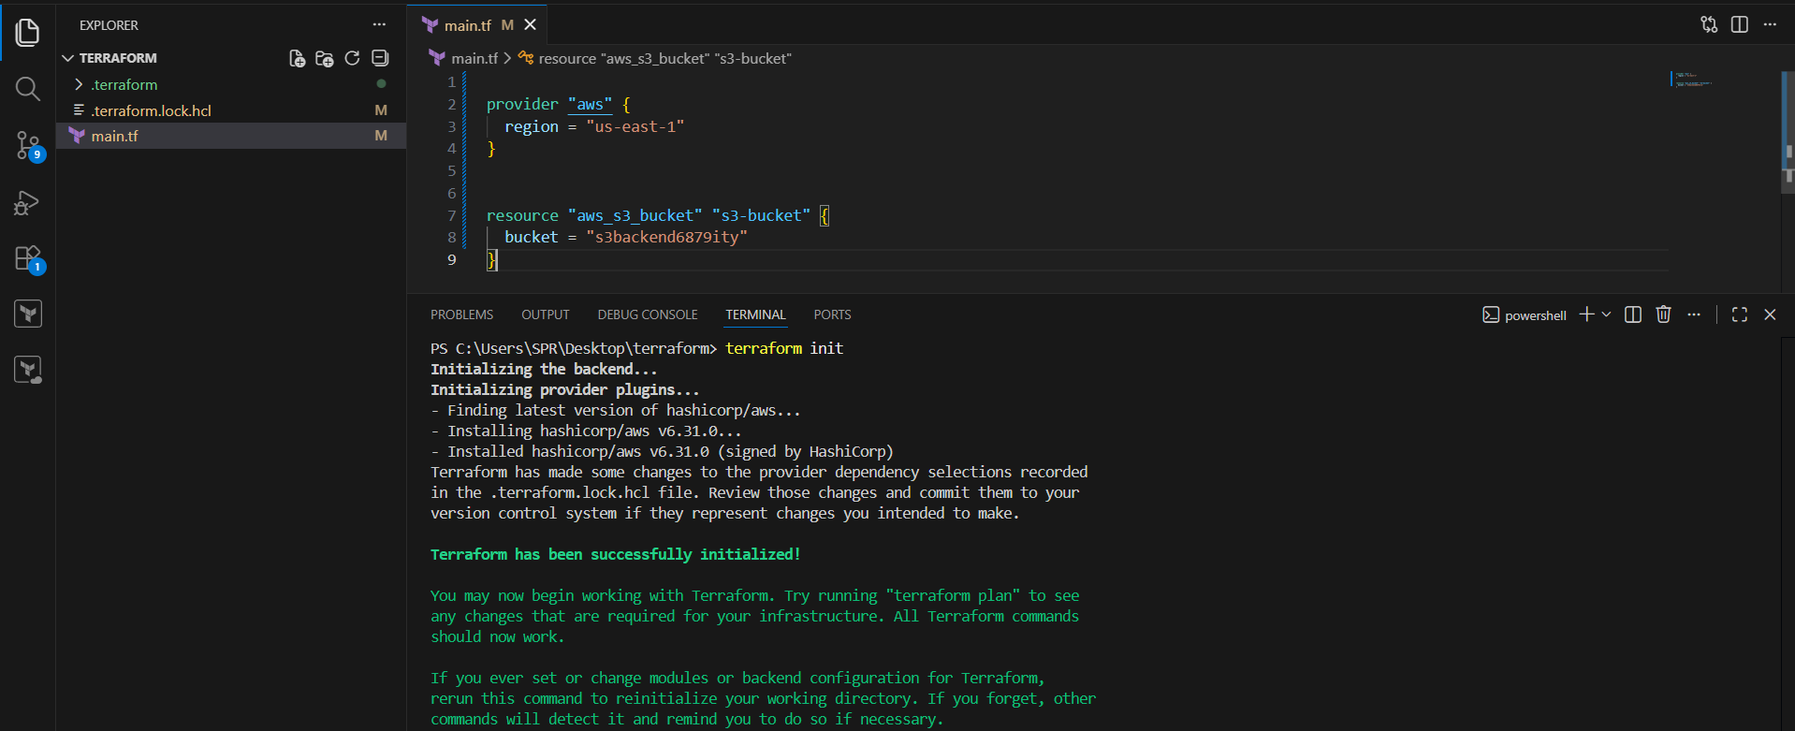

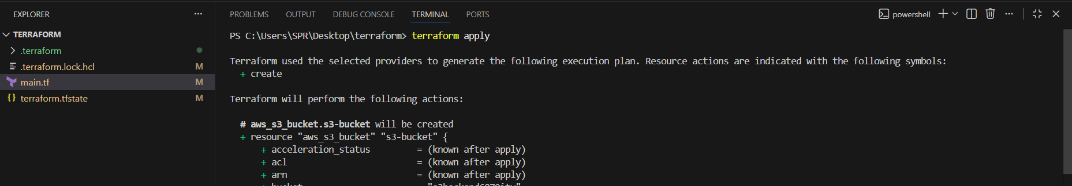
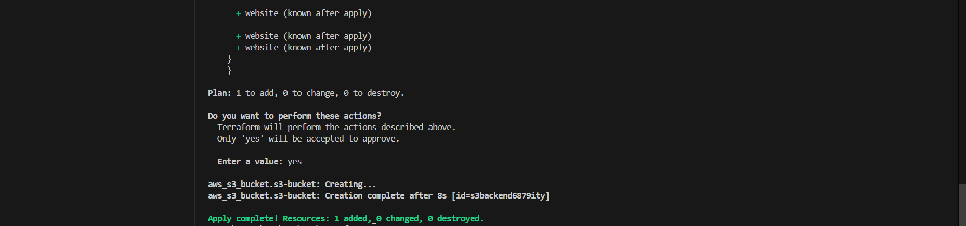

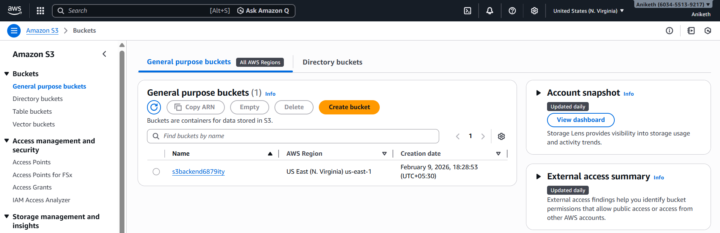

Create dynamo db using terraform:
================================
resource "aws_dynamodb_table" "dynamodb-terraform-state-lock" {
name = "terraform-state-lock-dynamo"
hash_key = "LockID"
read_capacity = 20
write_capacity = 20

attribute {
name = "LockID"
type = "S"
}
}

Update the main.tf file .

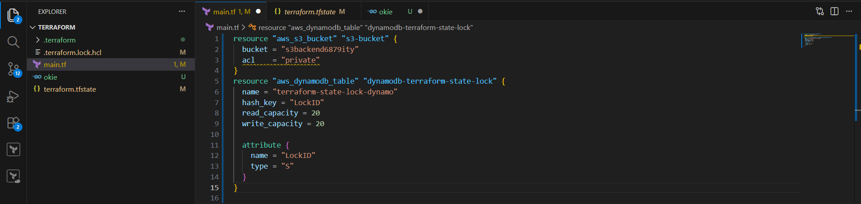

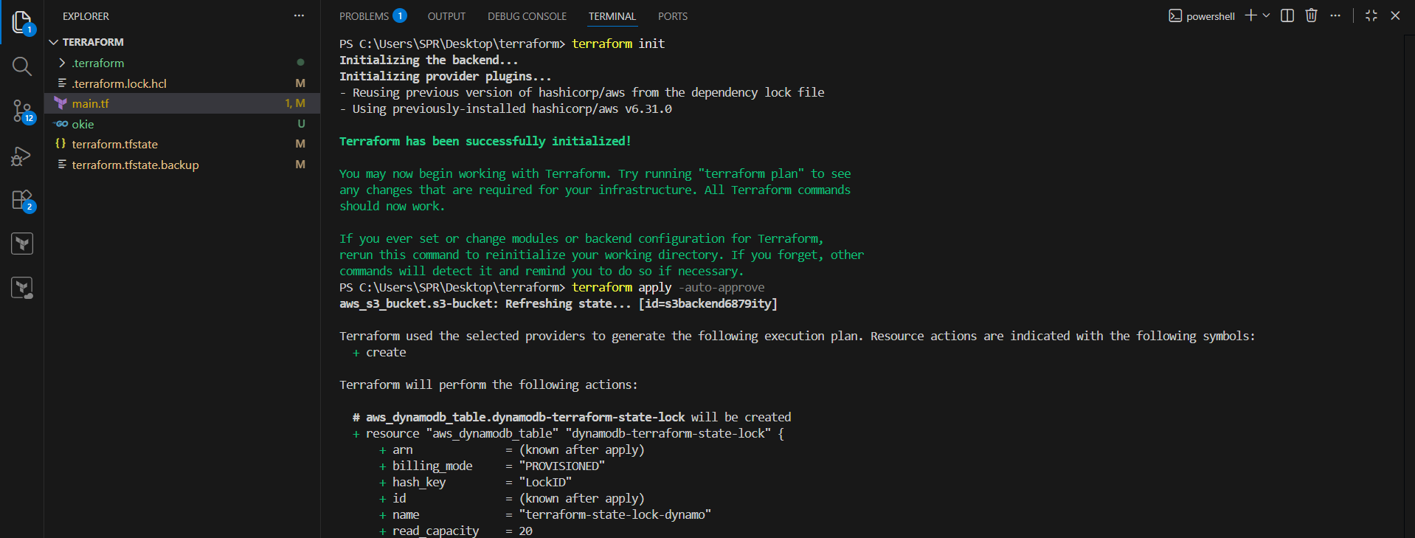
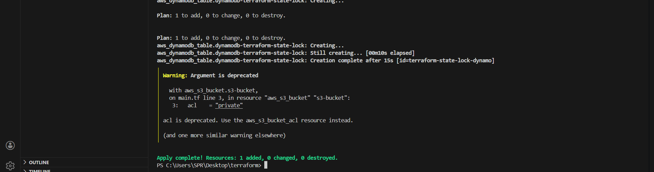

S3 as backend for terraform.tfstate file:
=========================================
terraform {
backend "s3" {
bucket = "s3backend"
dynamodb_table = "terraform-state-lock-dynamo"
key = "terraform.tfstate"
region = "us-east-1"
}
}

Update the main.tf file.

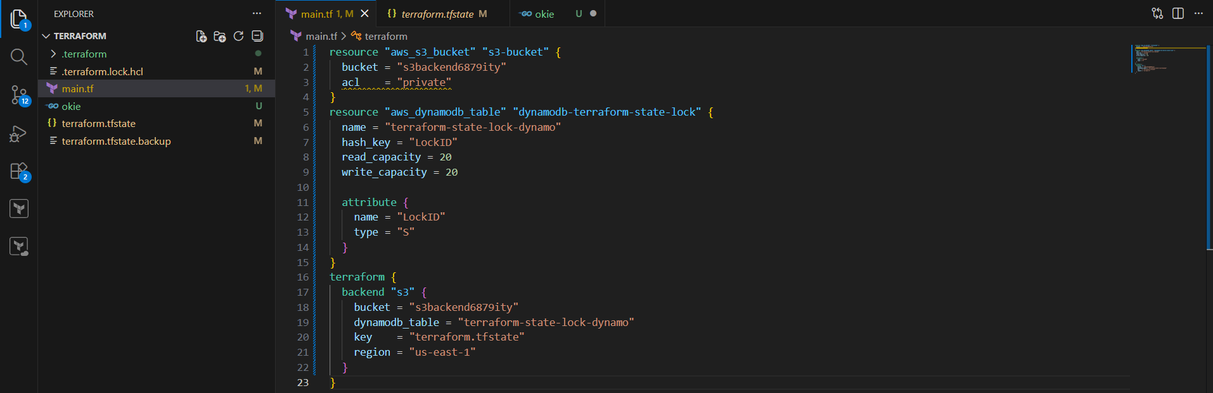

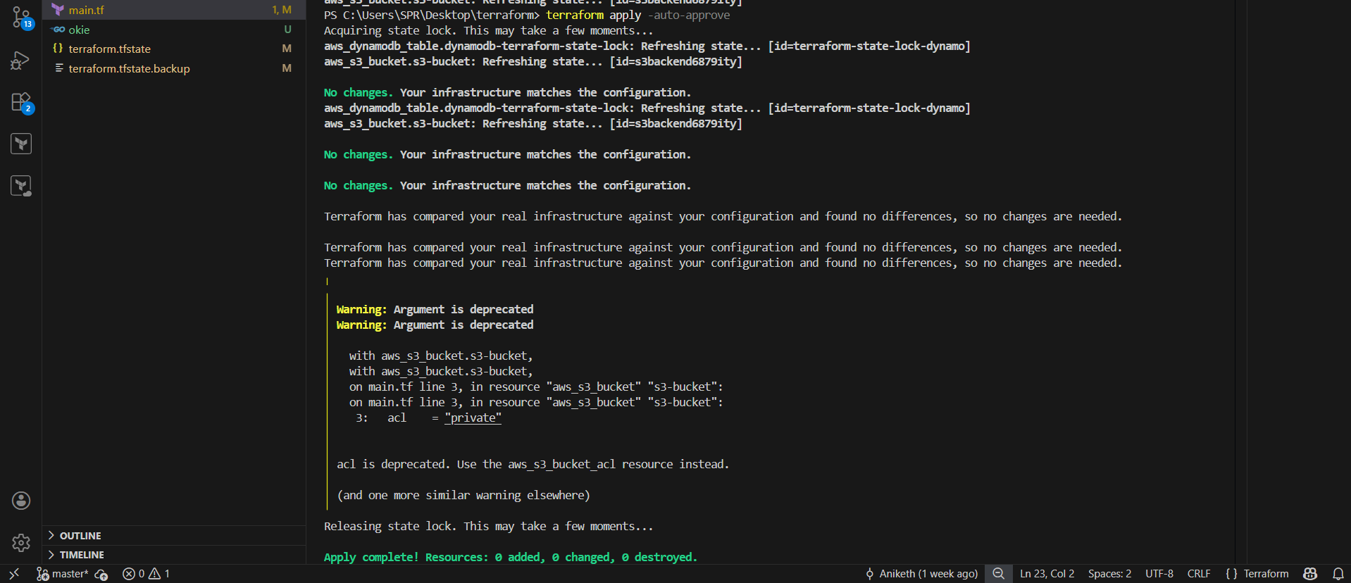

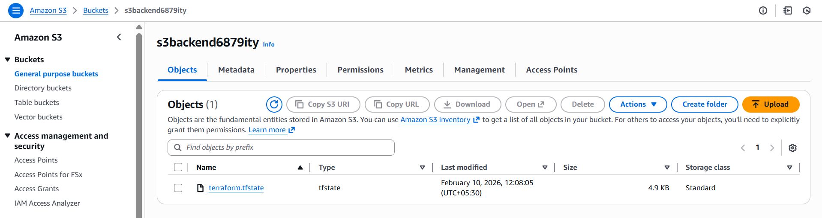

Terraform state commands:
========================
Terraform show --> To show the resources of the state file
Terraform state list --> List resources in the state
Terraform mv --> Move an item in the state
Terraform pull --> Pull current state and output to stdout
Terraform push --> Update remote state from a local state file
Terraform replace-provider --> Replace provider in the state
Terraform rm --> Remove instances from the state
Terraform show --> Show a resource in the state

Terraform Provisioners:
=======================
Terraform provisioners allow us to execute command,scripts on remote machines or
local place were terraform is installed.

Provisioners will be written inside the resource blocks.

We have two types of provisioners

1) Remote provisioner
This is used to execute commands at the run time on remote machines.
2) Local provisioner
This is used to execute commands at the run time on local machine. (means where terraform is installed).

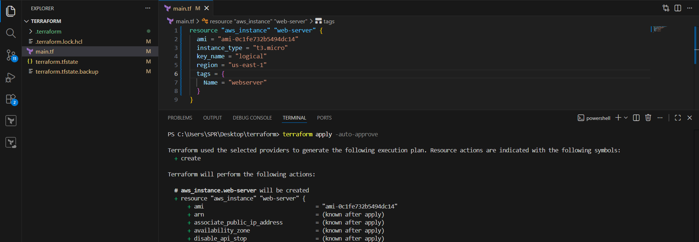
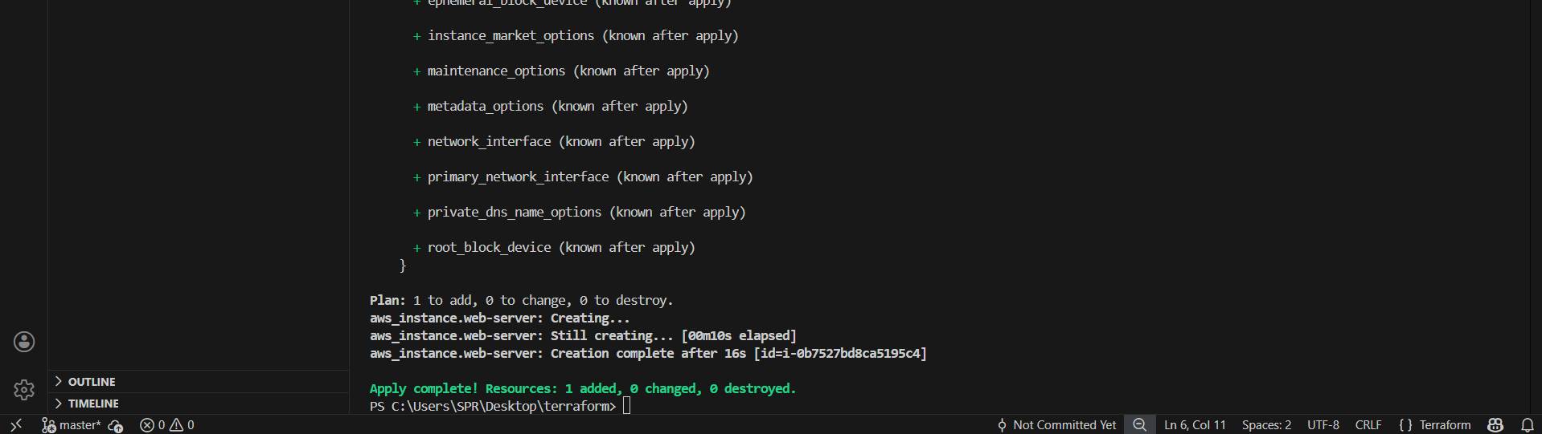

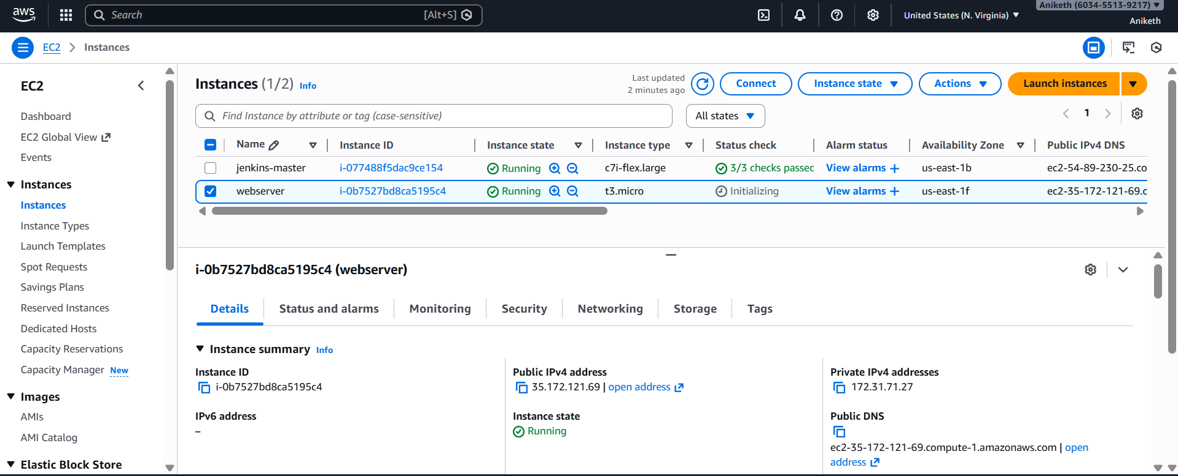

Example of Local provisioner:
============================
resource "aws_instance" "test-server" {
ami = "ami-005f9685cb30f234b"
instance_type = "t2.micro"
key_name = "linux-01"
tags = {
Name = "Test-server"
}
provisioner "local-exec" {
command = "echo Instance ${aws_instance.test-server.public_ip} created! > instance_state.txt"

}
}
We can use local provider after creating/destroying respource.

After destroy we need to add when condition in provisioner.
resource "aws_instance" "test-server" {
ami = "ami-005f9685cb30f234b"
instance_type = "t2.micro"
key_name = "linux-01"
tags = {
Name = "Test-server"
}
provisioner "local-exec" {
when = destroy
command = "echo Instance ${aws_instance.test-server.public_ip} created! > instance_state.txt"

}
}

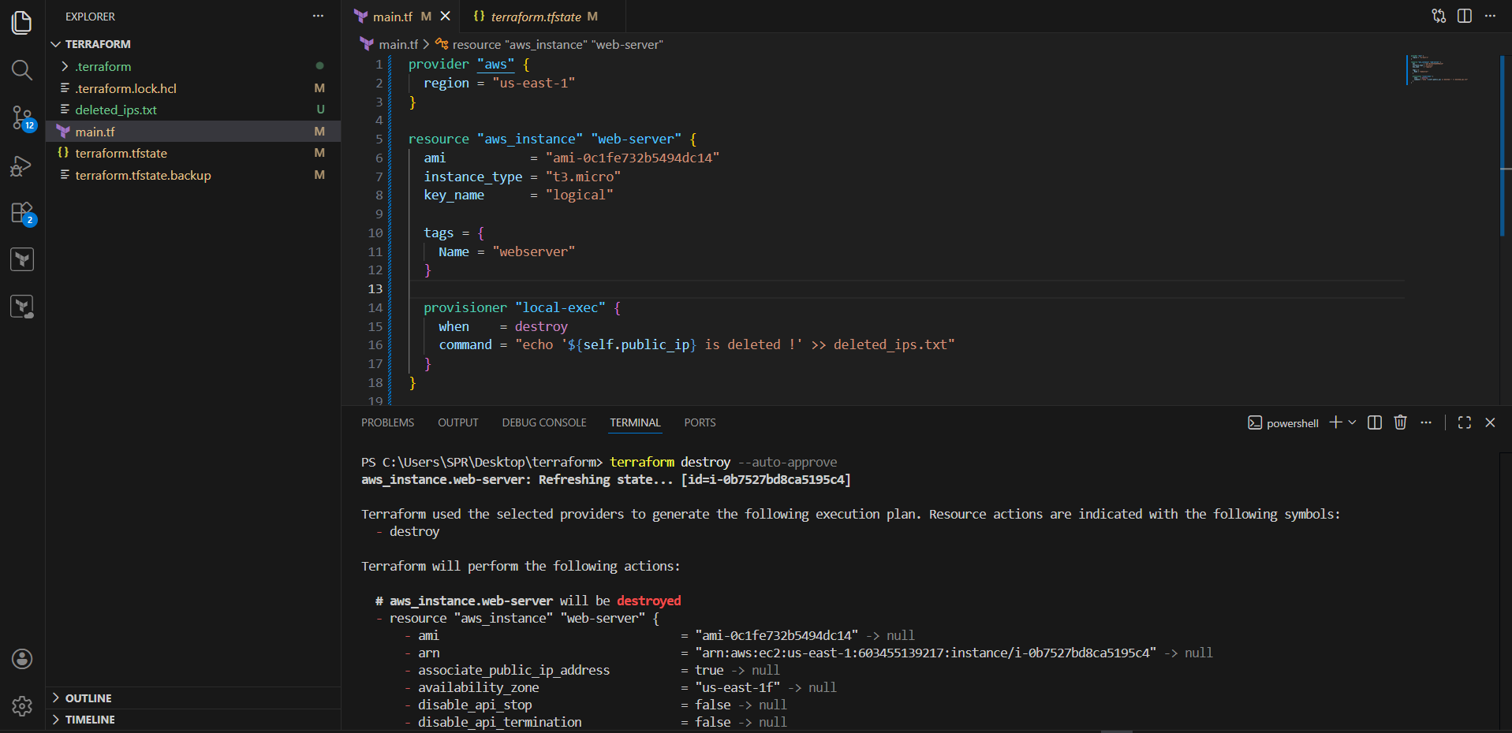
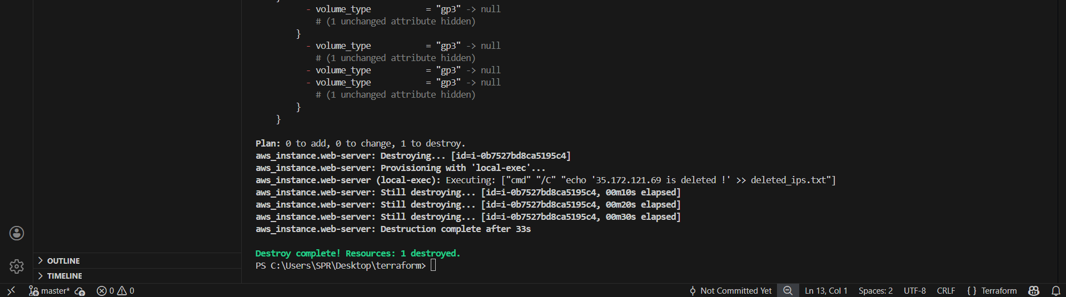

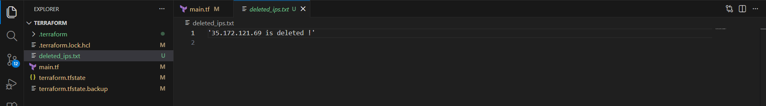

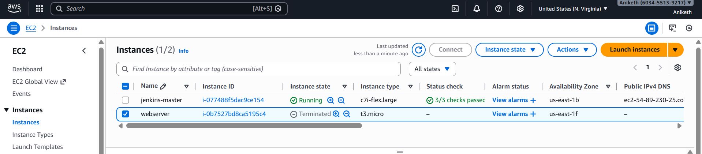

If the script failed then terraform apply command will also throw error.
if we want the resource to be completed if the script is failed then we can use on_failure module.

resource "aws_instance" "test-server" {
ami = "ami-005f9685cb30f234b"
instance_type = "t2.micro"
key_name = "linux-01"
tags = {
Name = "Test-server"
}
provisioner "local-exec" {
on_failure = fail
command = "echo Instance ${aws_instance.test-server.public_ip} created! > instance_state.txt"

}
}

Terraform provisioner behaviours:
=================================
1) Create at the time creating resource (Default)
2) create at the time of destroyin resource (when = destroy)
3) on_failure = fail --> to create the resource if the script gets failed.(But terraform will mark the reource as tainted)
4) On_fail = continue --> to create the resource and ignore the changes

Terraform taint and untaint:
============================
Thee would be cases when resource creation will get failed,if this happens
then terraform will be marked as "Tainted".
we can see this when we execute terraform plan command and this will
be replaced when we use terraform apply command.

if for any reason you have installed manually in ec2 and you want that to be replaced in next apply
then we can manually mark that resource as taint in terraform so that it will be replaced next time when use apply.

terraform taint aws_instance.webserver

to undo the changes we can use untaint command.

terraform untaint aws_instance.webserver

this resource will not be created when using terraform apply.

Debugging:
=========
terraform apply will provide us the logs/cause of the issue,
but still if we want to dig deeper then we need to export a varibale

export TF_LOG=TRACE
Set-Item -Path env:TF_LOG -value "TRACE"

Terraform provides 5 levels of logs:
1) INFO
2) WARNING
3) ERROR
4) DEBUG
5) TRACE

To store the logs permanently then we can export a path

export TF_LOG_PATH=/tmp/terraform.log
Set-Item -Path env:TF_LOG_PATH -value "terraform.log"

to unset or disbale logs
unset TF_LOG_PATH

Terraform import:
================
Terraform import is used to import the existing infrastructure in terraform state file.
Once import is done then we cna be able to create/delete and manage the infrastructure.

In order to import any resource we need to write the resource details in configuration file.

terraform import aws_instance.<name> instance_id

Before import we also need to add configuration block in main.tf

Example : In main.tf . add

resource "aws_instance" "manual" {
ami = "ami-02sd8dd6s5w963s5t"
Instance_type = "t3.micro"
}

Save and run the below command to import the instance.

terraform import aws_instance.manual i-0b7527bd8ca5195c4

- Create one EC2 instance with httpd installed using a Terraform script.

File: `main.tf`

provider "aws" {
region = "us-east-1"
}

resource "aws_instance" "httpd-server" {
ami = "ami-0c1fe732b5494dc14"
instance_type = "t3.micro"
key_name = "logical"
user_data = <<-EOF
#!/bin/bash
sudo yum update -y
sudo yum install -y httpd
sudo systemctl start httpd
sudo systemctl enable httpd
echo "Hello World from $(hostname -f)" > /var/www/html/index.html
EOF
tags = {
Name = "Terraform-httpd-server"
}
}

Commands to Run

```bash
terraform init
terraform plan
terraform apply
```

Type `yes` when prompted.

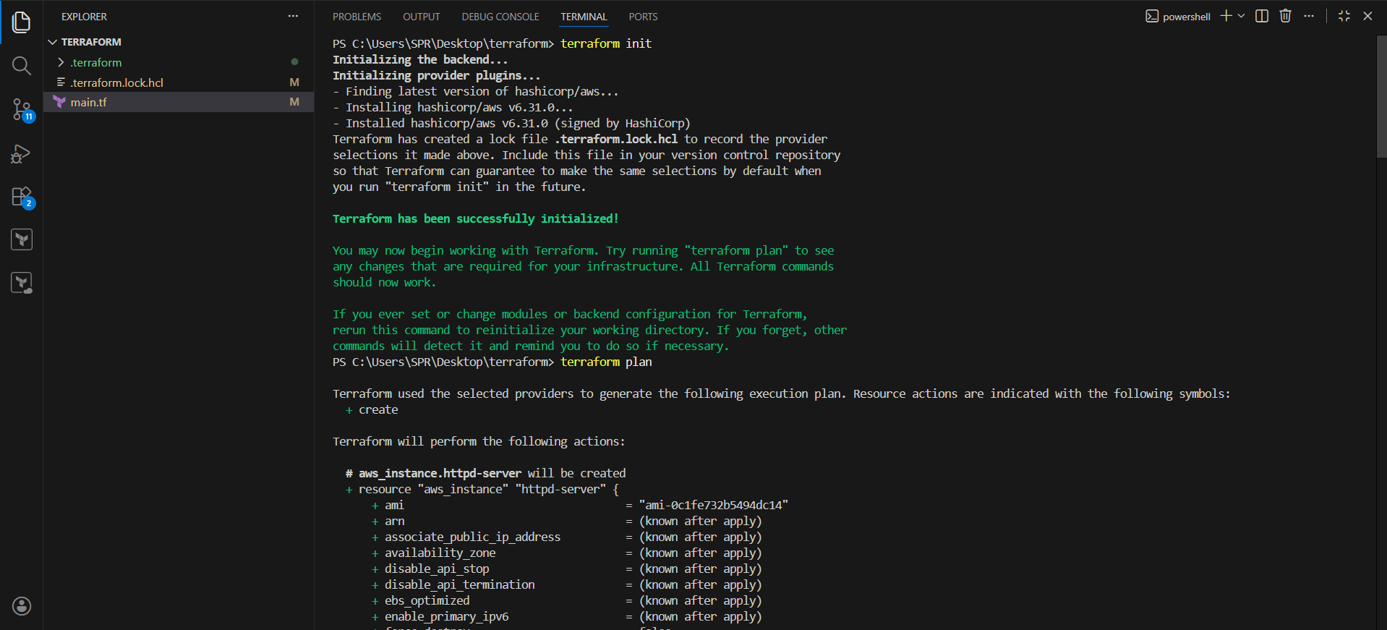

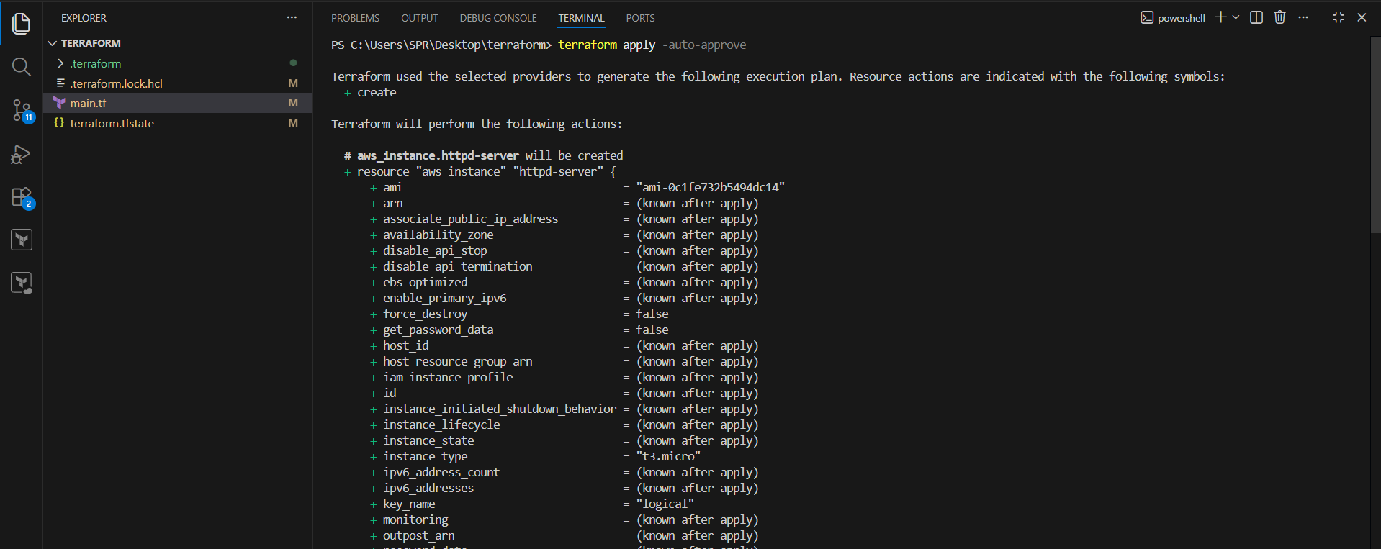
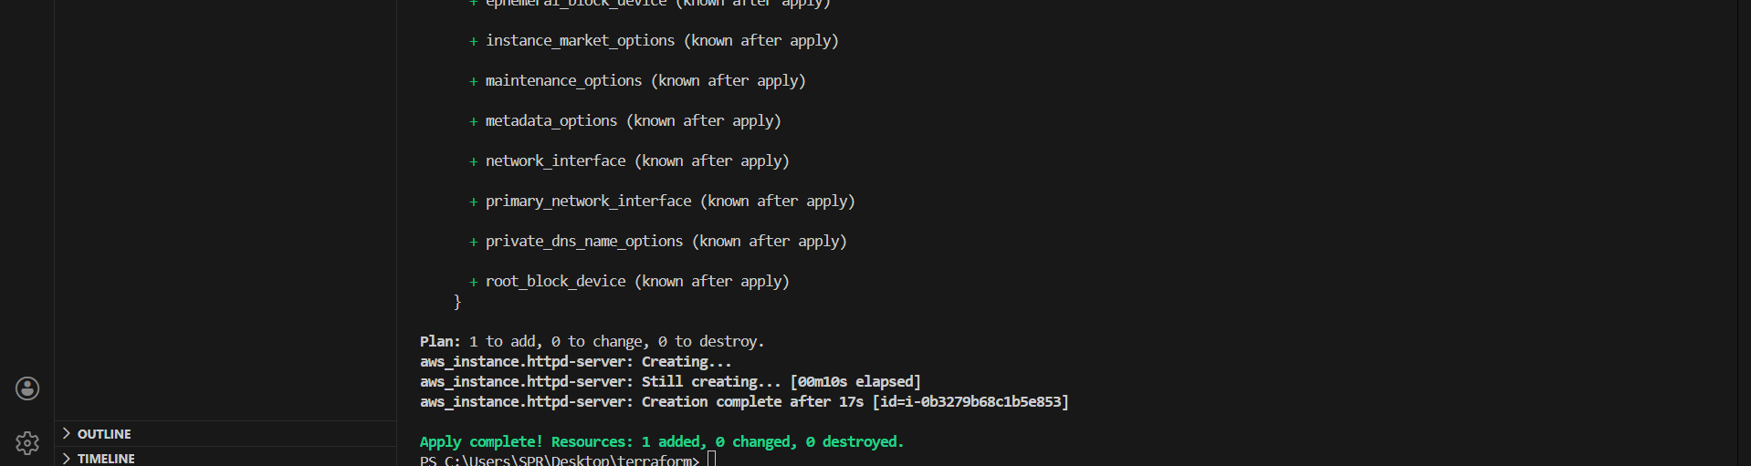

Succesfully instance created.

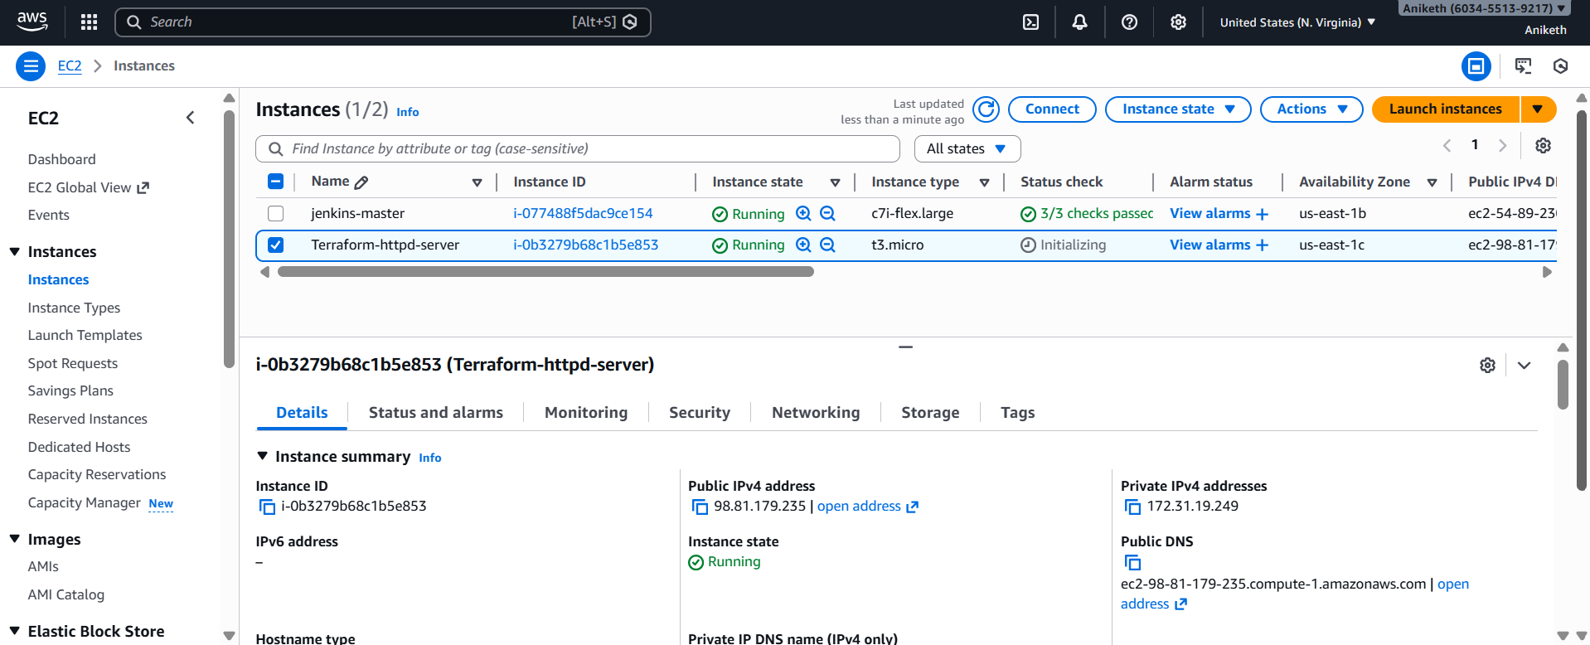

Access Apache

After apply completes:

1. Copy the **Public IPv4 address** from Terraform output or AWS Console
2. Open in browser:

```
http://<EC2_PUBLIC_IP>
```

You should see:

> **Apache is running on EC2 🚀**

Make sure default security group aloows port http -80 and ssh -22.

- Set up S3 as backend for above task .

Step 1 : Create a s3 bucket for backend.

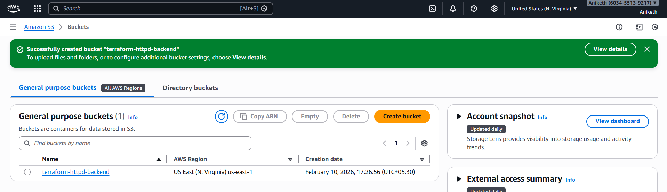

Step 2 : Update the main.tf [add s3 backend]

provider "aws" {
region = "us-east-1"
}

resource "aws_instance" "httpd-server" {
ami = "ami-0c1fe732b5494dc14"
instance_type = "t3.micro"
key_name = "logical"
user_data = <<-EOF
#!/bin/bash
sudo yum update -y
sudo yum install -y httpd
sudo systemctl start httpd
sudo systemctl enable httpd
echo "Hello World from $(hostname -f)" > /var/www/html/index.html
EOF
tags = {
Name = "Terraform-httpd-server"
}
}
terraform {
backend "s3" {
bucket = "terraform-httpd-backend"
key = "terraform.tfstate"
region = "us-east-1"
}
}

Step 3 : intitalize terraform

terraform init
it asks Do you want to copy existing state to the new backend?
Enter yes .

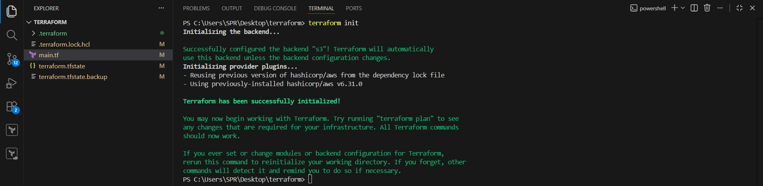

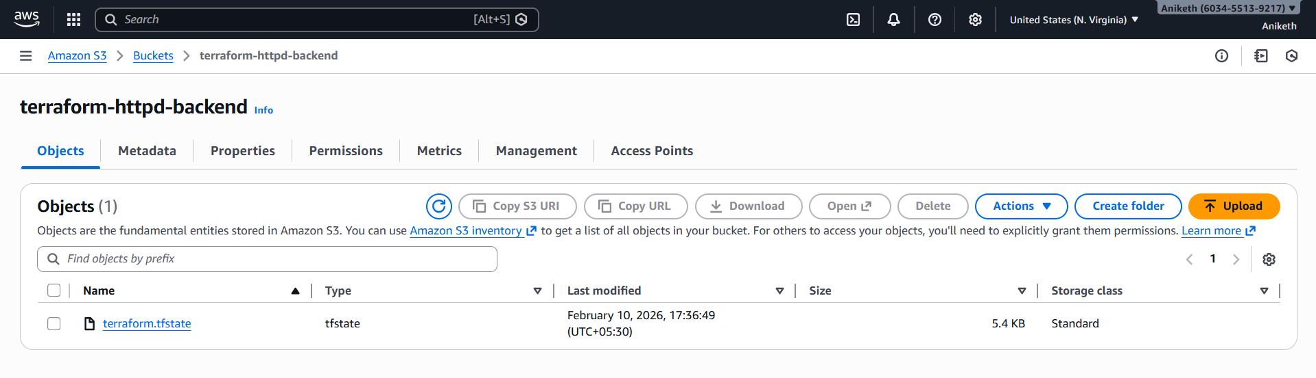

- Set up DynamoDB locking for task 3.

Step 1 : Update main.tf (add dynamodb in backend block)

provider "aws" {
region = "us-east-1"
}

resource "aws_instance" "httpd-server" {
ami = "ami-0c1fe732b5494dc14"
instance_type = "t3.micro"
key_name = "logical"
user_data = <<-EOF
#!/bin/bash
sudo yum update -y
sudo yum install -y httpd
sudo systemctl start httpd
sudo systemctl enable httpd
echo "Hello World from $(hostname -f)" > /var/www/html/index.html
EOF
tags = {
Name = "Terraform-httpd-server"
}
}
terraform {
backend "s3" {
bucket = "terraform-httpd-backend"
key = "terraform.tfstate"
region = "us-east-1"
dynamodb_table = "terraform-state-lock-dynamo"
}
}

Step 2 : initialize terraform .

Terraform init (or) terraform init -migrate-state.

Succesfully dynamodb locking enabled .
we can check it if we perform “terraform apply” , it shows aqiring the statelock.

